New consulting centre for additive manufacturing

The KSB Group has created a new consulting and testing centre for additive manufacturing at its Pegnitz location. Drawing on over ten years of experience in additive manufacturing, the pump and valve manufacturer wants to help other companies to set up their own production facility.

KSB’s portfolio of services in this area ranges from advice on selecting the right equipment to developing design skills and production expertise as well as testing materials and components.

KSB was the first ever manufacturer to receive TÜV certification for additive manufacturing of components subject to the European Pressure Equipment Directive. Since KSB is well equipped with 3D printers for metal, in addition to producing its own spare parts the company is also able to offer contract manufacturing of components from other industries.

At its Pegnitz location, the KSB Group has been developing and researching metal materials for over a hundred years, in particular for corrosive and abrasive applications in process engineering. It has so far developed over 300 alloys in the areas of cast iron, unalloyed steels, bronze, stainless steels and duplex steels. These alloys are used in numerous demanding applications around the world.

As the lot sizes for such applications tend to be rather small, the casting experts started exploring manufacturing techniques for casting production very early on in this new field. Additive manufacturing is therefore an ideal technology for KSB since it allows new design solutions to be quickly developed and implemented.

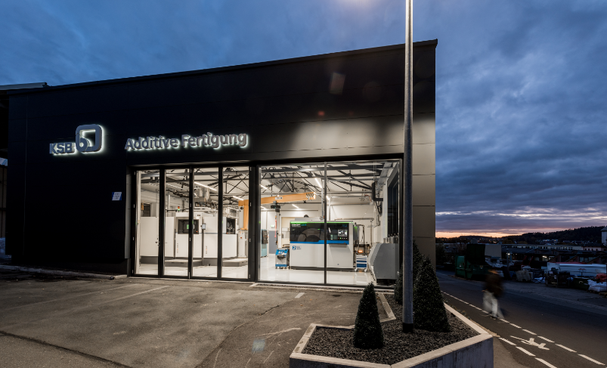
Photo 1: In the new consulting and testing centre for additive manufacturing the KSB Group offers an extensive range of services. (© KSB SE & Co. KGaA)

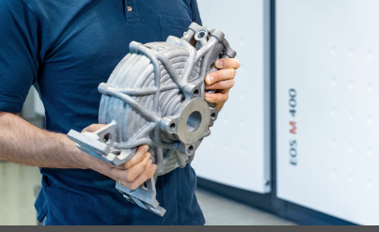
Photo 2: Pump casings like these were unable to be manufactured with classic production methods. (© KSB SE & Co. KGaA)

